ICA/SUV 2026 Annual International Conference and Fifth Workshop on Scientific Archives

The University Archives and Research Institutions Section of the International Council on Archives is pleased to announce ts annual conference, to be held at the University of Coimbra , Portugal, in collaboration with the Committee on Archives of Science and Technology and the Department of Life Sciences of the University of Coimbra.
The event has the support of the Center for the History of Society and Culture (CHSC), the Center for Functional Ecology (CFE), and the Portuguese Association of Librarians, Archivists, and Information and Documentation Professionals (BAD).

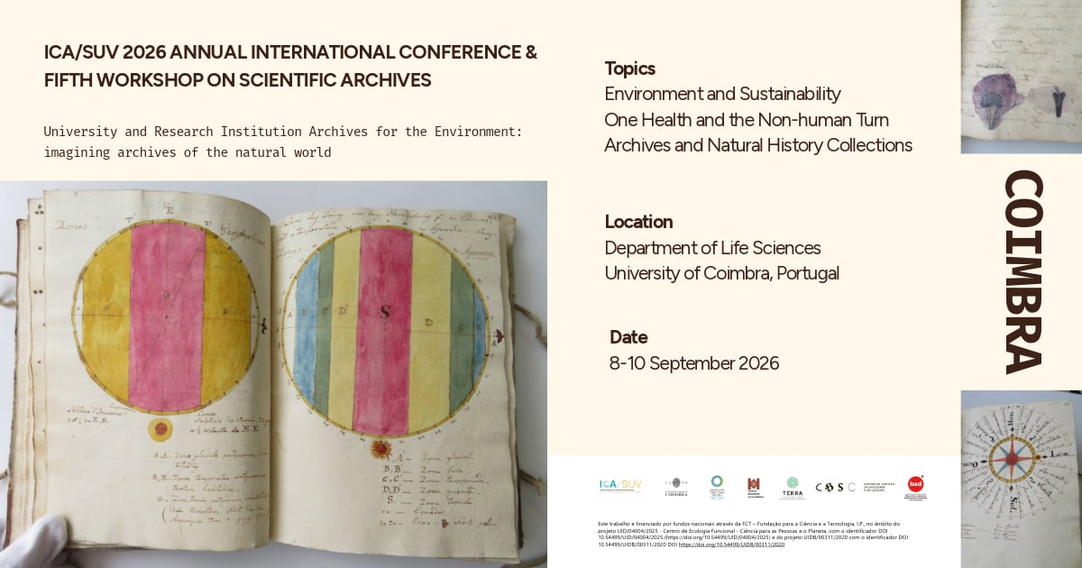

The conference theme covers the following topics:
- Environment and Sustainability
- One health and non-human turn (archives and collections that demonstrate the interconnection between human and environmental health)
- Natural History Collections (including their links to indigenous knowledge systems and colonial practices)

PROGRAM
Tuesday 8th September 2026
8.00 – 9.00 Registration
9.00 – 9.30 Welcome session
Delfim Leão, Vice-Rector, University of Coimbra
Ana Maria Gama da Silva, Director of the Department of Life Sciences, University of Coimbra
Caroline Brown, Chair, Section on University and Research Institution Archives, International Council on Archives
Paula Meireles, Vice-President, Portuguese Association of Librarians, Archivists, Information and Documentation Professionals
Ana Margarida Dias da Silva, Chair of the Local Conference Committee

9.30 – 10.30 Keynote Speaker: Cláudia Castelo, University of Lisbon
Chair: Fernanda Rollo, Faculty of Social Sciences and Humanities NOVA University of Lisbon, History, CFE - Territories and Communities
Scientific archives of Empire and the production of knowledge in post-colonial societies
Cláudia Castelo, University of Lisbon

10.30-11.00 Break

11.00-12.30 Session 1: One Health: exploring the links between animal and human
Chair: Jorge Varanda, Department of Life Sciences, University of Coimbra, Centre for Research in Anthropology (CRIA)

One Health through the lens of historical patient records and human ecology research
Polina Ilieva, Associate University Librarian for Archives and Special Collections and Library Development, University of California, San Francisco (UCSF)
Life, Environment, and Archives: AI-Driven Reinterpretation of the Joan Oró Holding within a One Health Framework
Pepita Raventós Director Archives and Records Management Unit and Adrià Font, Archival Technician, University of Lleida
Pulling a tiger out of the hat: finding the unexpected in animal related collections at the University of Edinburgh
Fiona Menzies, Project Archivist, University of Edinburgh

12.30 – 1.45 Lunch
1.45 – 3.15 Session 2: Addressing colonial connections
Chair: António Carmo Gouveia, Department of Life Sciences, University of Coimbra, Centre for Functional Ecology (CFE)

Invisible Hands, Visible Traces - Local Collaborators and the Archival Afterlives of Diamang’s Scientific Production in Colonial Angola (1947–1974)
Diogo Rocha, Master Student, Department of Life Sciences, Ana Margarida Dias da Silva (CHSC), Helena Freitas (CFE) and Jorge Varanda (CRIA), Department of Life Sciences, University of Coimbra
Invisible Collectors, Imperial Collections: Networking the Colonial Herbaria of Kolkata and Kew
John Schaefer, PhD Student, University of Cambridge

Contested Collections of Angolan Primates Shipped to Germany, a case-study of provenance metadata enhancement for zoological collections and databases
Catarina Madruga Researcher Technische Universität Berlin and Catarina Santos, PhD Student, FCT-NOVA Lisboa
3.15 – 3.45 Break
3.45 – 5.15 Session 3: Global perspectives on energy sector archives
Chair: Kolya Abramsky, Special Advisor on Archives, World Wind Energy Association

Archives Portal Europe and Eogan energy archives network: creating new history connections in the digital sphere
Marta Musso, Archives Portal Europe and Sapienza University, and Daniel Moreno Medina, independent researcher, cognitive artist

Other Speakers TBC
Tuesday Evening: Reception – City Hall time TBC

Wednesday 9th September 2026
9.30 – 10.30 Keynote speaker: Fernanda Ribeiro, University of Porto, Portugal
Chair: Maria Beatriz Marques, Faculty of Arts and Humanities, University of Coimbra, Transdisciplinary Culture, Space and Memory Research Centre (CITCEM)

The University of Porto Archives: preserving institutional memory and promoting the use of information in management
Fernanda Ribeiro, Full Professor, University of Porto, Portugal, Transdisciplinary Culture, Space and Memory Research Centre (CITCEM)

10.30-11.00 Break
11.00-12.30 Session 1: Pushing the archival boundaries: the role of non-textual records
Chair: Anne-Flore Laloe, Information Management Officer · EUMETSAT

Natural history as resistance – Korbinian Aigner's pictures of apple and pear varieties
Dr. Katrin Bäumler, Head of Archives, Technical University of Munich
A Teaching Herbarium in the Archive: Amos Eaton, Science and the Natural World During the Industrial Revolution
Jenifer Monger, Institute Archivist and Matthew Golebiewski, Archivist, Rensselaer Polytechnic Institute
From Repository to the Landscape: Rethinking Archaeological and Environmental Evidence as Archival Primary Sources
Brenda Gunn Associate University Librarian for Special Collections and Preservation University of Virginia
12.30 – 1.30 Lunch
1.30 – 3.00 Session 2: Data and discoverability
Chair: Ana Lúcia Terra, Faculty of Arts and Humanities, University of Coimbra, CEIS20 - Centre for Interdisciplinary Studies

Microscopes, Shipwrecks, and Chameleon Eggs: Reconstructing Knowledge Networks in 18th-Century Natural History Archives
Ilaria Maggiulli, Archivist and Lucia Giagnolini, Archivist, University of Bologna Historical Archive
Avenues to enhance discovery of 100 years of analogue scientific research data in university archives: lessons from a pilot study
Stephanie Sparrow, Agriculture and Social Sciences Librarian, University of Minnesota-Twin Cities, USA

Archives as Active Research Infrastructures: Evidence from the University of Coimbra Scientific Repository
Susana Jarmelo, Bibliometrics Specialist, University of Coimbra

3.00 – 3.30 Break
3.30 – 4.30 Session 3: Lightning talks
Chair: Polina Ilieva, Associate University Librarian for Archives and Special Collections and Library Development, University of California, San Francisco (UCSF)

From Personal Scientific Archives to Institutional Records – The David C. H. Florance Archives
Garfield Lam, University Archivist, University of Hong Kong

An Environmental History of Penn State University: Using Institutional Archives to Explore Interactions Between a University and the Natural World
Ben Goldman, University Archivist, Penn State University

An Elephant Never Forgets: Zoological Archives in Amsterdam
Emma Morse, Collections Manager and Archivist, ARTIS, Amsterdam Royal Zoo

"Public transport is good for you": Creative Engagement with Climate Change Materials in the Campaign for Better Transport Archives at the National Railway Museum
Kait Buchbaum, Archive Cataloguer, National Railway Museum and Michael Solomon Williams, Head of External Affairs, Campaign for Better Transport

4.30 ICA-SUV AGM
Wednesday Evening: Conference Dinner time TBC

Thursday 10th September
9.30-11.00 Session 1: Collecting and preserving environmental records
Chair: Ana Margarida Dias da Silva, Department of Life Sciences, University of Coimbra, Center for the History of Society and Culture (CHSC)

Governing AI-Mediated Environmental Research Records in University Archives
Kenneth Atuma, Lecturer in Information Studies, The University of Manchester
Sustaining Climate Archives: Navigating Political, Environmental, and Resource Constraints
Julie Judkins, Associate Professor, Special Collections & Archives Department Head
Nature, Science and Man: a 1970s multidisciplinary environmental science course that still has a voice
Deirdre Bryden, University Records Archivist, Queen's University Archives

11.00-11.30 Break
11.30 – 13.00 Session 2: Supporting environment
Chair: Paula Meireles, Head of the Archive, Documentation and Information, Foundation for Science and Technology (FCT), Portuguese Association of Librarians, Archivists, Information and Documentation Professionals (BAD)

Imagining Sustainable Higher Education Archives: Future Strategies for the Porto Polytechnic Archive
Milena Carvalho, CITCEM/FLUP/CEOS/ISCAP - P. Porto / Lecturer at ISCAP Polytechnic of Porto, Susana Martins CEOS/ISCAP - P. Porto / Lecturer at ISCAP Polytechnic of Porto and Olga Ferreira University of Salamanca / Centro de Cultura do Porto.
Assessing Environmental Sustainability Practices in University Archives: A Survey of Federally Chartered Universities
Muhammad Mirza, Principal Librarian and Dr. Muhammad Hamidullah, Librarian, International Islamic University, Islamabad

Developing a Course of Action for Practicing Archivists on the Environmental Impact and History of Archives
Dr. Eric Carlos, Stoykovich College Archivist and Manuscript Librarian, Trinity College. Hartford, Connecticut

14.30 – 17.00 Visits: Cultural Program
General Archive of the University of Coimbra, Library Joanina of the University of Coimbra, Botanic Garden of the University of Coimbra

Throughout the conference poster sessions will be available, titles and participants TBC.

REGISTRATION – https://ucstore.uc.pt/pt/event/conferencia-internacional-anual-icasuv-2026-e-quinto-workshop-sobre-arquivos-cientificos-12/register
Reduced fee until 30th June
Registration as an ICA or BAD member (subject to provision of supporting documentation) – 130€
Regular registration – 150€
Student fee (subject to provision of supporting documentation) – 100€

Regular fee from the 1st of July
Registration as an ICA or BAD member (subject to provision of supporting documentation) – 150€
Regular registration – 180€
Student fee (subject to provision of supporting documentation) – 110€

